Assignment 1
Assignment 1 provides experience with creating an Access database. This assignment should be started while you are reading the first three chapters.. In addition you should read carefully the problems at the end of chapter 3 and chapter 4 describing the Customer Order Entry data base. You should save the database that you create in this assignment because you will need it for later assignments.

1. Create Database
Begin by creating a new database with “JASorderentry” as the database name, where you replace JAS with your initials. I suggest that you create the database on the local hard disk. To protect yourself from a failure, copy your database file to a USB drive, or CD before finishing. I strongly advise that you keep a backup copy of your database. You can copy the database file using the Windows Explorer.

2. Import Data

Start Microsoft Access and select new for a new file and use the blank data base template. Enter the desired name of your data base. Select External Data from the top level ribbon menu. Use the Import command to load each of the data tables with the data shown in the textbook chapter 4 pages 121-124 To populate your database, use the ASCII files that are stored in the customerorder.zip file under the assignment section of blackboard.
- Select the external data menu bar from the upper ribbon and use text files.
- Provide the full path name of the customer text file by using the browse selection.
- Select to import the source data to a new table in the current data base.
- Select fixed width with columns and spaces between each field.
- For field1 be sure to change the selection to indexed no duplicates, this will create a primary key.
- Choose your own primary key of field 1
- Enter the name of the table to be imported
- Click finish and close
Your first data table has just been completed.
Repeat the above steps for the importing of other data tables.
Please heed these points as you use the Import Wizard to create the tables.
- The primary key for customer table is CustNo.
- The primary key for OrderTbl table is OrdNo.
- The primary key for Employee table is EmpNo.
- The primary key for Product table is ProdNo.
- The OrdLine Table must have Allow Duplicates selected for the field OrdNo. You must specify the Primary Key for OrdLine Time after the import. Use the Design View and select the Ordno and Prodno first two rows and then select the Primary Key icon.

3.0 Modify Table Definitions

After creating the tables and importing the data, modify the table definitions created by the Import command. Access chooses the Data Type and Length properties based on the data that was loaded. In most cases, the guess is correct. For most other properties, you must modify them. You can find a description of the properties in Chapters 1 and 2. Set these properties as suggested below. Enter the data field names and data types for each of the data fields as shown below. Remember to specify correct data types of currency for the last field of customer balance, date fields and quantity fields etc. Remember to define the ProdNo field as indexed with allow duplicates for the OrdLine table.

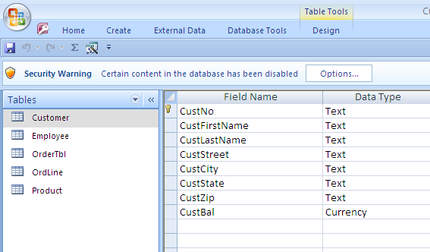

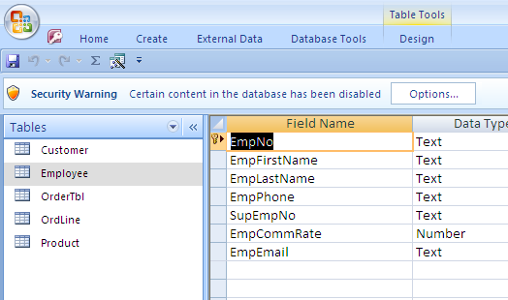

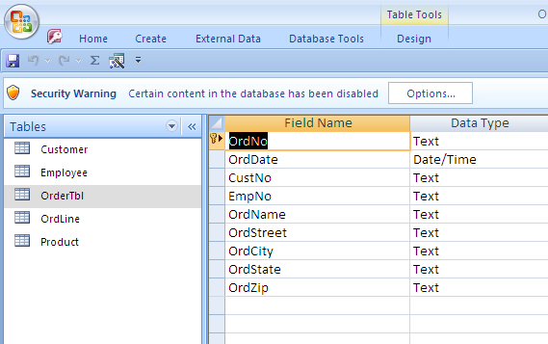

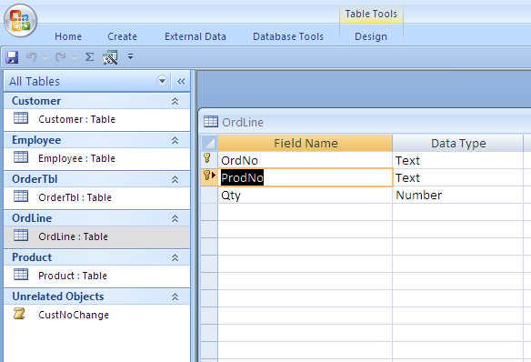

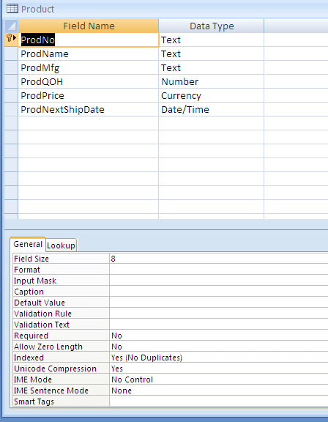

4. Define Relationships

Select the Database Tools Menu Item from the top ribbon bar. Click on the Relationships menu. Add each of the tables to the relationship window. Position the tables as shown in Figure 4.P1 on page 121 of your text book. Click on the Relationship Tools Menu from above the menu bar. Select Edit Relationships Create New. Use the Relationship Window to define relationships as shown in the textbook Chapter 4, Figure 4.P1 on page 121. Choose Enforce Referential Integrity for each relationship. Set the Cascade Delete/Update Related Records properties for the relationships as follows:
Customer and OrderTable
Ordline and OrdTable,.
Read pages 49-52 of Chapter 3 for an explanation of referential Integrity.
Add the Employee Table Twice to the relationship window. This will enable the employee table to be linked to the employee’s supervisor.

Grading
If you follow the instructions, you should receive full credit. Here are my grading guidelines:
- A major error such as not loading table is a deduction of 15 points.
- A medium error such as not defining a relationship or incorrectly specifying a primary key is a deduction of 10 points.
- A minor error such as an inappropriate data type (for example text instead of numeric for quantity) is a deduction of 5 points.
- Please be sure to compare you relationship diagram to that shown in the book on page 121. Please email me the resulting Microsoft Access File.

